Circuit Diagrams
L.O: To use symbols to represent components of electrical circuits
Task: Draw a diagram of the circuits below using the correct symbols.
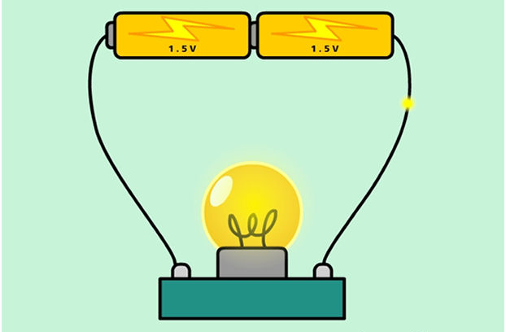
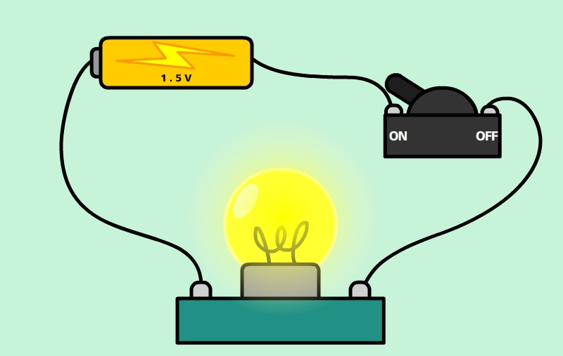

EXT: Draw a diagram of your own circuit that includes a bulb, buzzer and switch.

