LO: To plan and conduct a scientific investigation
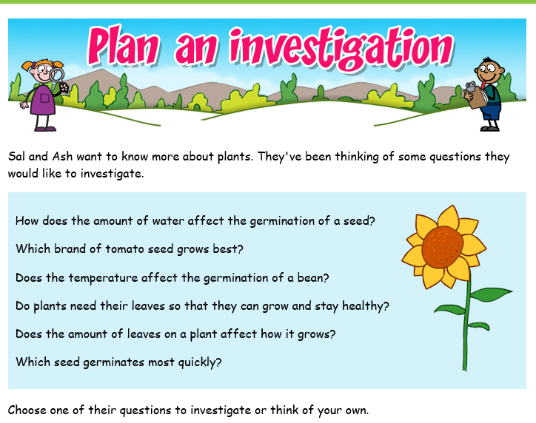

Try to use some of these scientific skills in your investigation:
- Plan your enquiry by deciding if you need to carry out a fair test.
- Make accurate repeated measurements and record your observations/measurements carefully in a table.
- Produce a graph showing your results
- Write about any patterns in your results and explain what you have found out

