Tropical and temperate rainforests have been subjected to heavy logging and agricultural clearance throughout the 20th century and the area covered by rainforests around the world is shrinking Biologists have estimated that large numbers of species are being driven to extinction due to the removal of habitat with destruction of the rainforests. Here are some facts about the World’s Rainforests which shows how important they are to animals and the planet.
Did you know that 57% of all rainforests remaining are located in the Neotropics, with 30% located in Brazil?
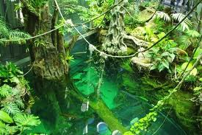
Largest rainforests worldwide listed in descending order (from largest to smallest).
- Amazon basin of South America
- Congo river basin of Central Africa
- S.E. Asia
- New Guinea
- Madagascar

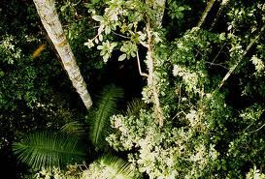
Brazil has the highest annual rate of deforestation today.
Madagascar Rainforest

Deforestation refers to the cutting, clearing, and removal of rainforest or related ecosystems into less bio-diverse ecosystems such as pasture, cropland, or plantations.
Central America has lost 50% of its rainforests.
South America has lost 70% of its rainforests.
Philippines Rainforest
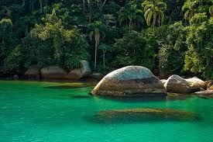
Rates for Rainforest Destruction:
2.4 acres per second: equivalent to two U.S. football fields.
Soil erosion happens when trees and plants are removed; the rain water washes the nutrients in the top soil away.

Atlantic coast of Brazil has lost 90-95% of its rainforest.
El Salvador has lost 70-85% of its rainforest due to heavy bombing during the civil war 1984-1985.

Brazil’s Rainforest
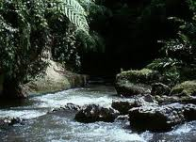
An impact of deforestation:
Loss of culture.
Indigenous people are people who live in the rainforest. They depend on the natural environment for everything.
Without the rainforest they could become seriously ill.
Ways you can lessen deforestation:
- Use pencils until they are stubs!
- Recycle paper, cans, glass, and plastic.
If the current rate of deforestation continues, the world's rain forests will vanish within 100 years- causing unknown effects on global climate and eliminating the majority of plant and animal species on the planet.

Only 6% of Central Africa's forests are protected by law.
Sumatra’s Rainforest
Did you know that tropical rainforests, which cover 6-7% of the earth's surface, contain over half of all the plant and animal species in the world?

